<Attachment>
How to register“2022 Study in Korea Education Fair with Local Governments”
- Visit the Study in Korea website“www.studyinkorea.go.kr”
- Click “2022 Study in Korea Online Education Fair with Local Governments”
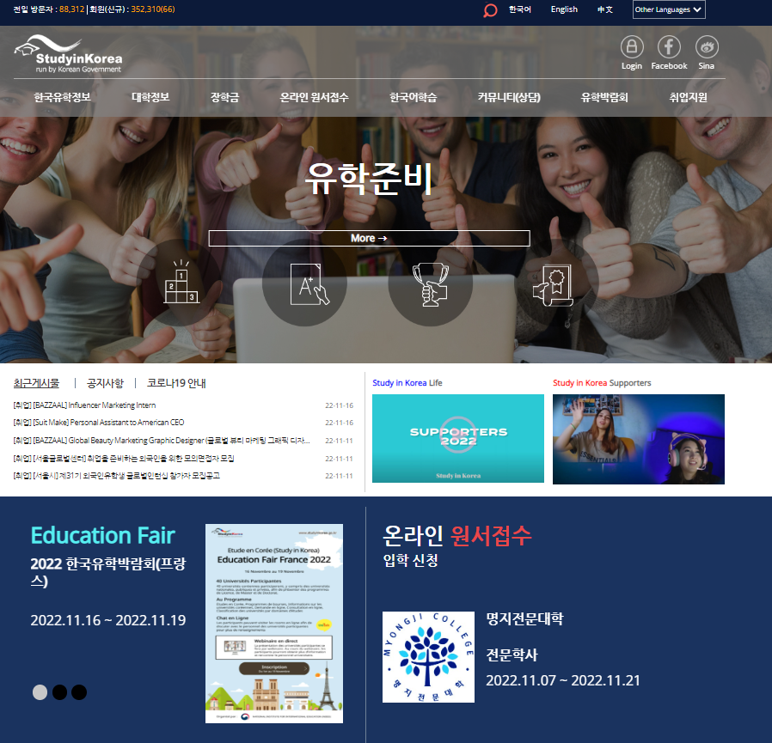

- Click “Registration” to join the Fair.
- Please visit the education fair page during the period of Nov 22nd (Tue) ~ Dec 1st (Thu).

